**Climate Finance Short Course**

Annual 5 day course for government officials from developing countries

Venue: Dhaka, Bangladesh

Dates: 31st January -4th Feb 2015

**Registration form**

|  |  |  |
| --- | --- | --- |
| **Given Name** |  | **Photo** |
| **Family Name** |  |
| **Gender (M/F)** |  |
| **Title(Mr/Ms/Dr)** |  |
| **Nationality** |  |
| **Email address** |  | |
| **Organisation** |  | |
| **Position** |  | |
| **Postal address** |  | |
| **Telephone**  (Please include area code.) |  | |
| **Date of birth**  **(DD/MM/YY)** |  | |
| **Main are of your work**  *(E.g. country, region, sector, role, etc.):* |  | |
| Please tell us what you hope to get out of the course, and how you envisage using the skills and knowledge gained in your work (this helps us to make the course as relevant as possible) |  | |
| Please list topics of in which you are particularly interested that may be relevant to the course |  | |
| Please let us know if you have any special dietary or other requirements |  | |
|  |  | |

Please send your completed registration to [**neha.rai@iied.org**](mailto:neha.rai@iied.org), with copy to [mahmudsabuj11@gmail.com](mailto:mahmudsabuj11@gmail.com)and[marek_soanes@hotmail.com](mailto:marek_soanes@hotmail.com)of International Institute of Environment and Development (IIED) and International Centre for Climate Change and Development***. Please find overleaf the draft outline of the programme***

Thank you very much

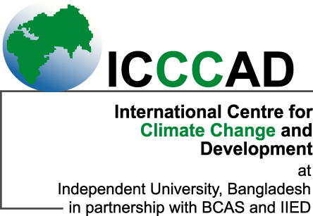

**Climate Finance Short Course**

**Bangladesh, 31st January—4th February 2016,**

**Rough Outline**

|  |  |
| --- | --- |
|  | **Broad outline – 5 days** |
| **Jan 31st/Day 1** | **Overview of Climate Finance** |
|  | * **Welcome and Introduction** * Peer to peer learning * Building a Network * **Feedback on training needs** * **National climate finance** (Landscape of national climate finance arrangements, Public Finance Management (PFM),   national financial institutions in climate change, budget codes and tracking mechanisms)   * **International climate finance** (Types and sources  of finance, development finance and climate finance, modalities of international climate funds) * **Group Discussions** |
| **Feb 1st/ Day 2** | **Getting climate finance to those who need it most** |
|  | * **Sub-National Climate Finance** (local finance needs, role of local governments and cities, NGOs) * **Private Climate Finance** (Public finance catalysing private climate finance, national development banks, international financial institutions, SMEs, MFIs, carbon markets) * **Group Discussions** |
| **Feb 2/ Day 3** | **Field Trip** |
|  | Field trip to relevant climate project (eg IDCOL solar water systems) |
| **Feb 3/ Day 4** | **Group Discussions** |
|  | - Climate finance in Bangladesh : opportunities and challenges  - Selected Topics for small group discussion (eg national, international, sub-national, private, others) and to agree future action |
| **Feb 4/Day 5** | **Next steps for Peer to Peer Learning** |
|  | - Participants Presentations of Future Action  - Mentoring  - Future learning opportunities  - Certificates and Closing Dinner |

